
THE TREEHOUSE PRIVATE
KINDERGARTEN AND NURSERY
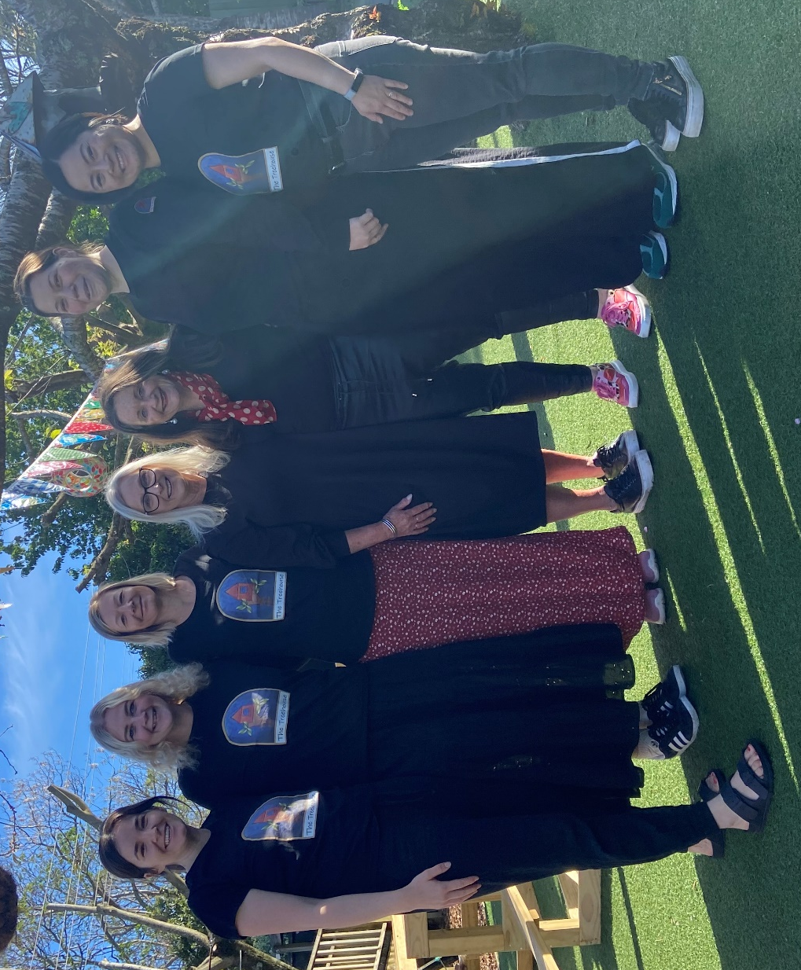
STAFF QUALIFICATIONS
Kathryn Clout (Directress/Owner) BTchLn Dip ECE, Dip Management (Reg: Full: 197913)
Rachel Grieve – Educator BA Honours BTchLn (Reg: Full: 406668)
Olivia Van Hengel - Educator BTchLn (Reg: Full: 408210)
Cathy Duytshoff – Educator BTchLn Dip Mon (Reg: Full:254057)
Kamila Lyons – Educator BTchLn (Reg: Full:374807)
Merlye Pan – Educator BTchLn (Reg: Full: Full: 412322
Trina Remi – Educator BTchLn

